**K23-0593**

**Muhammad Ayesh**

**Lab-2**

**TASK 1:**

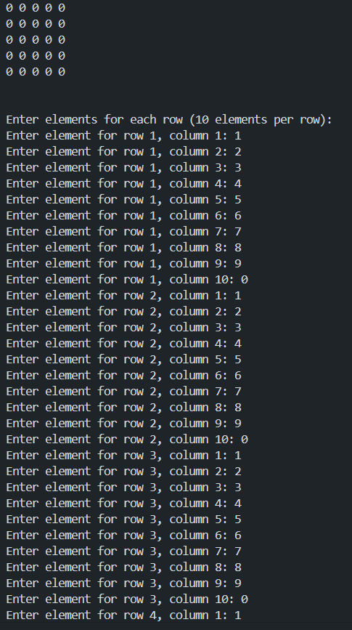

**TASK 2;**

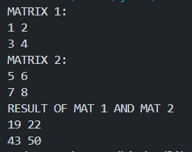

**TASK 3:**

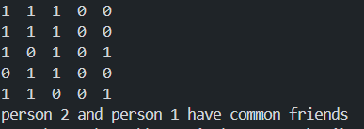

**TASK 4:**

**TASK 5:**

